LCV5 4G Global BLE Modem Firmware OTA update instructions

1.Connect the devices to the PSU:

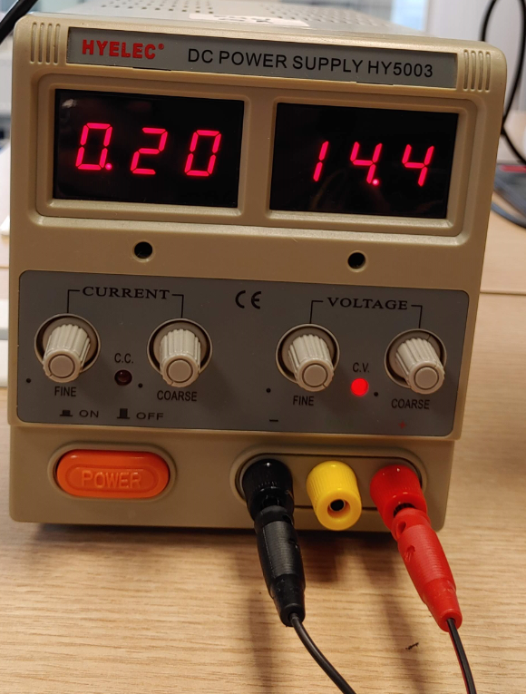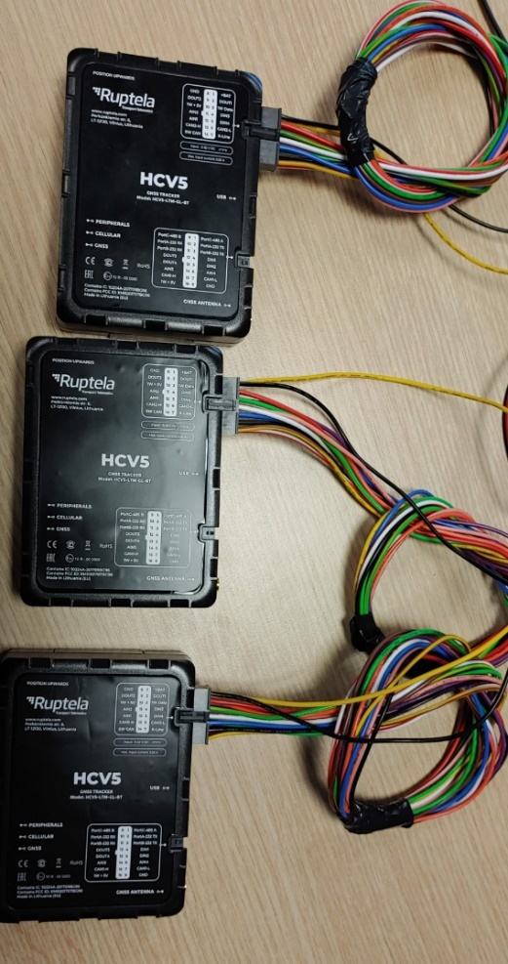 Make sure your Power Supply Unit (PSU) has enough power for the number of devices you are planning to flash in one go. The standard requirement is 1A per device. Operating voltage is between 12v-30v. (e.g. if you are connecting 3 devices to the PSU, max available current should be at least 3A). While idle, the devices might seem to consume quite less power, but during flashing procedure it can spike.

(This type of PSU would let flash 5 devices in one go:

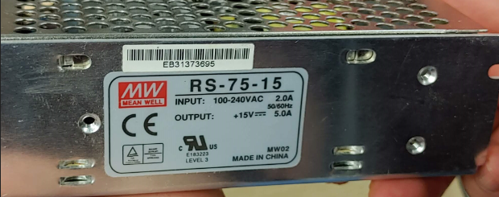)

2. Connect the Type A – micro B USB port:

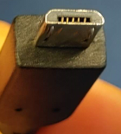

To the micro b port on the device:

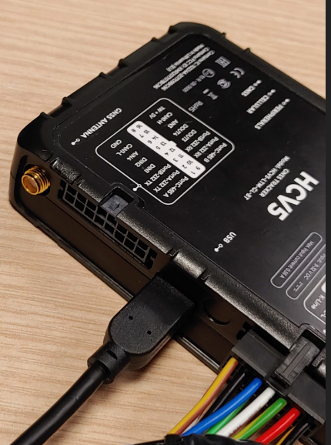

Make sure your PC recognizes it as USB COM port in your device manager (win+x -> device manager on win 10)

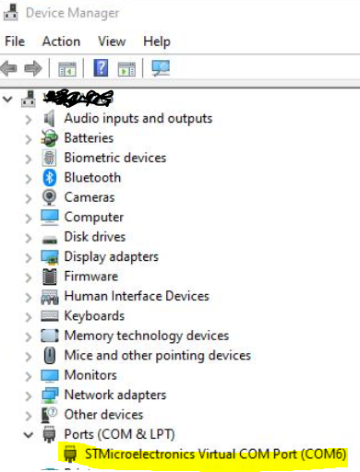

If the device is not being recognized as virtual com port please download driver pack from

<https://doc.ruptela.lt/display/AB/Drivers+and+utilities>

unzip the file, and run the file corresponding to your system 64 or 32bit\*.

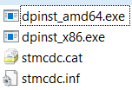If this does not work, try changing USB port on your PC, and cable. Any cable that can charge and be used for data transfer for older Android phones should work.

\*you can check this win+x -> system



3. Open ModemAnalyser.exe and follow these instructions

3.1 Select correct port as pictured above in device manager:

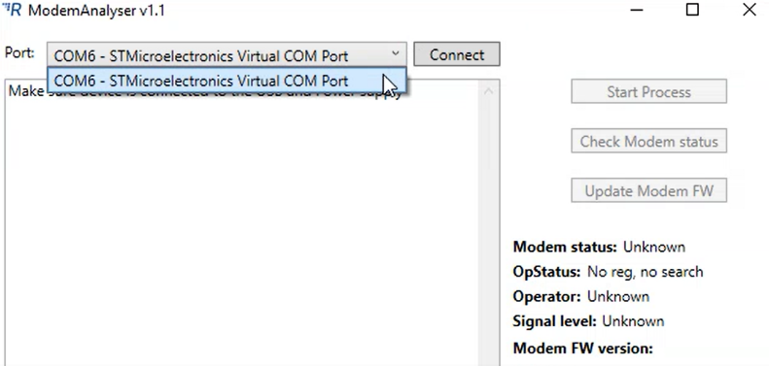4. And press Connect: (your Modem FW version should appear:

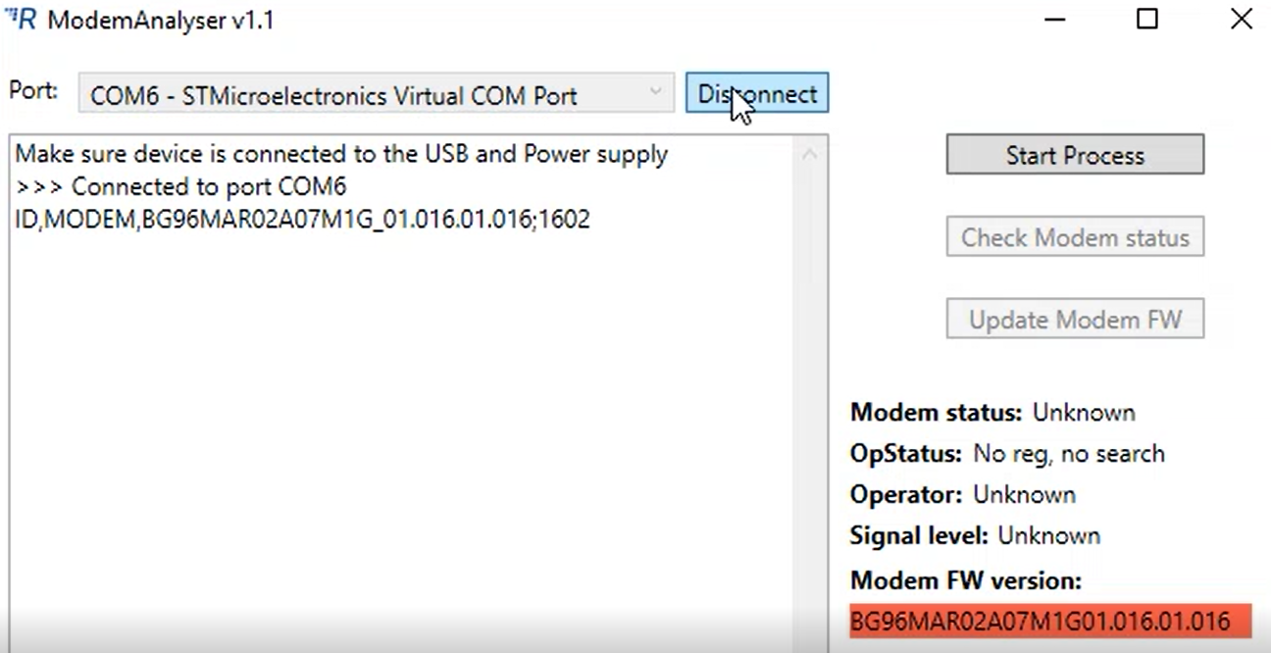

5. If yes- press start process:

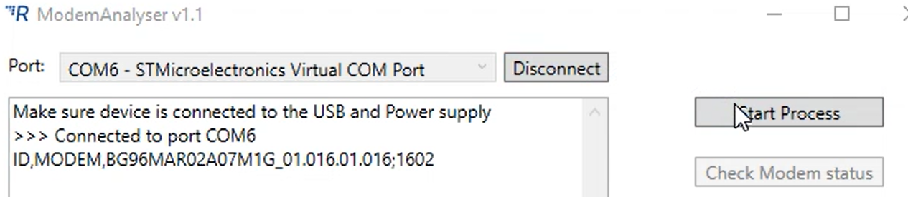

If you get this message – press no:

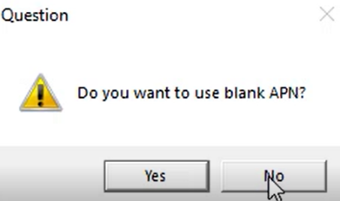

6. Enter your correct APN settings below (i.e. APN: claro.com.br, User: claro, Pass: claro)

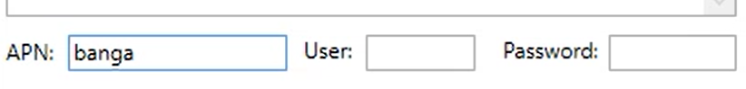

7. Press start process:

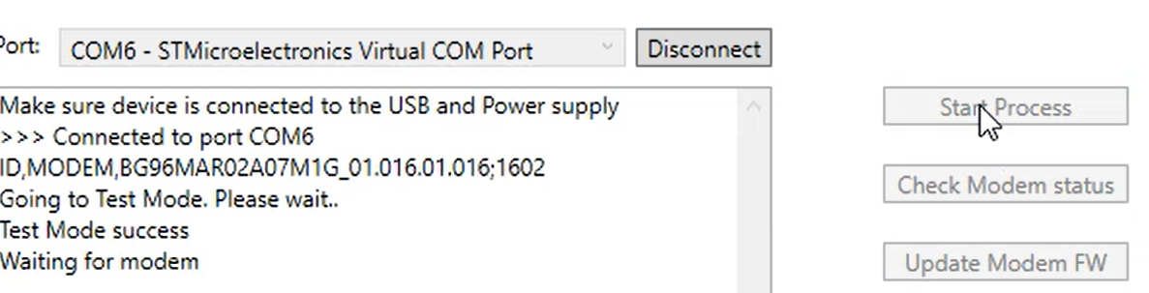

It might take some time – wait until OP status changes:

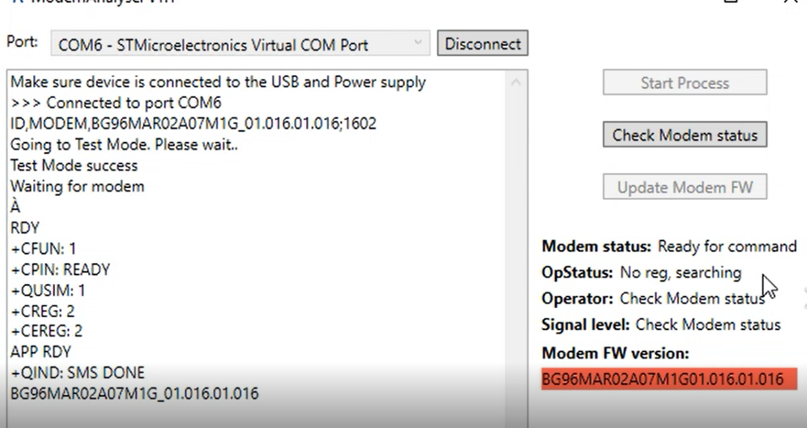

8. When OpStatus changes to registered, you can press the check modem status button again, to see signal level, if they are very low, please move the devices to better coverage area. Press Update Modem FW:

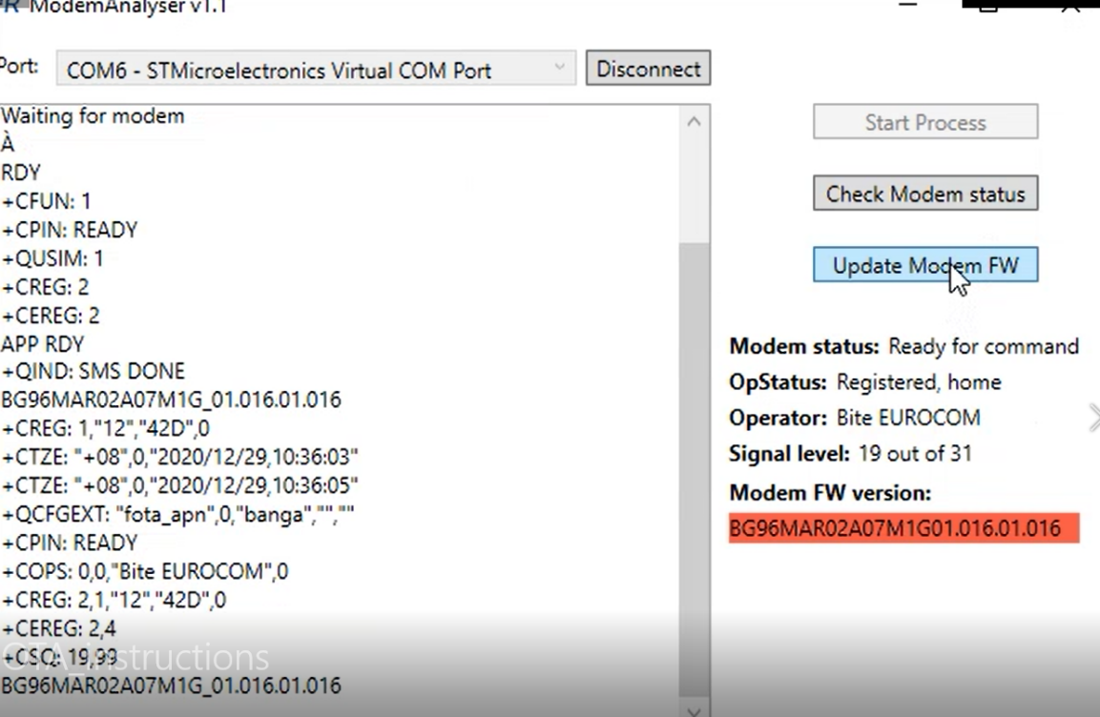

9. You should get the command – DFOTA update initiated:

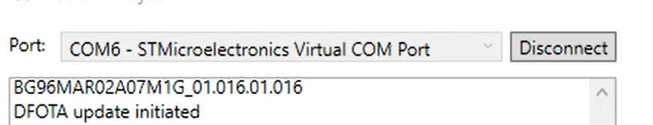

That’s it – please leave the device connected to the PSU (device can finish update on its own), unplug the USB cable, plug it into the next device, and follow steps 4-9.

10. When the OTA update is initiated on all the devices, you need to give them from 15 to 30 minutes, connect the USB to the first device, click Connect and see if modem FW has been updated:

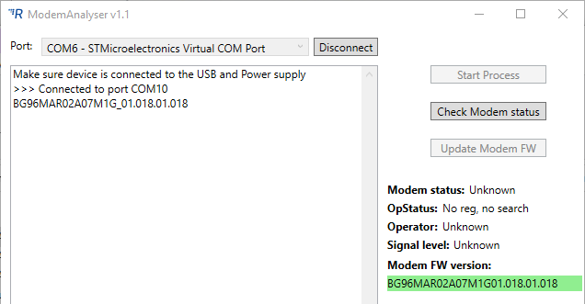

If device is printing something this like this, that means update is still in progress: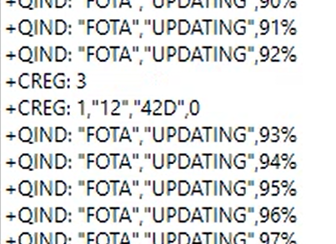or 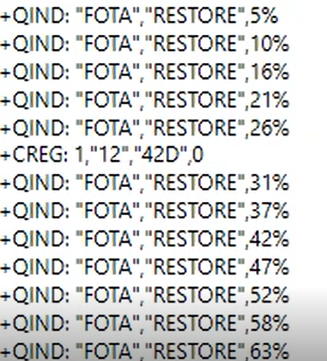

Green modem FW version confirms that update was successful, you can disconnect the device:

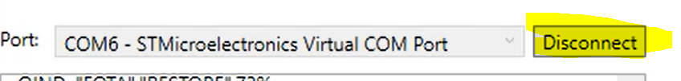

Connect the next one. Rinse and repeat.

Troubleshooting tips

If update takes longer than one hour, try changing SIM card. During our testing in Brazil best results were achieved with Claro SIM card. Keep in mind that one OTA update consumes about 6Mb of data. Data plan should be sufficient enough.

If any other problem occurs, disconnect device completely (LEDs should be off), restart ModemAnalyzer and try update process again. Keep in mind that in some cases it is necessary to unplug internal battery to turn off device properly.

Modem FW version doesn’t appear after connecting to the device:

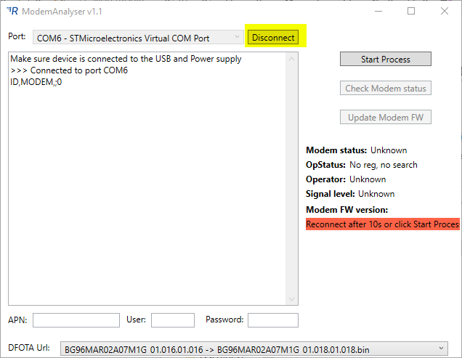

Wait 5-10s, disconnect and connect to the device by clicking yellow button.

When contacting support by email, please include the logs or screenshots from the ModemAnalyser (email address to be added here later)